# List Methods (2) - Python Exercise

Below is the image provided along with the recreated question, terminal output, and answer:

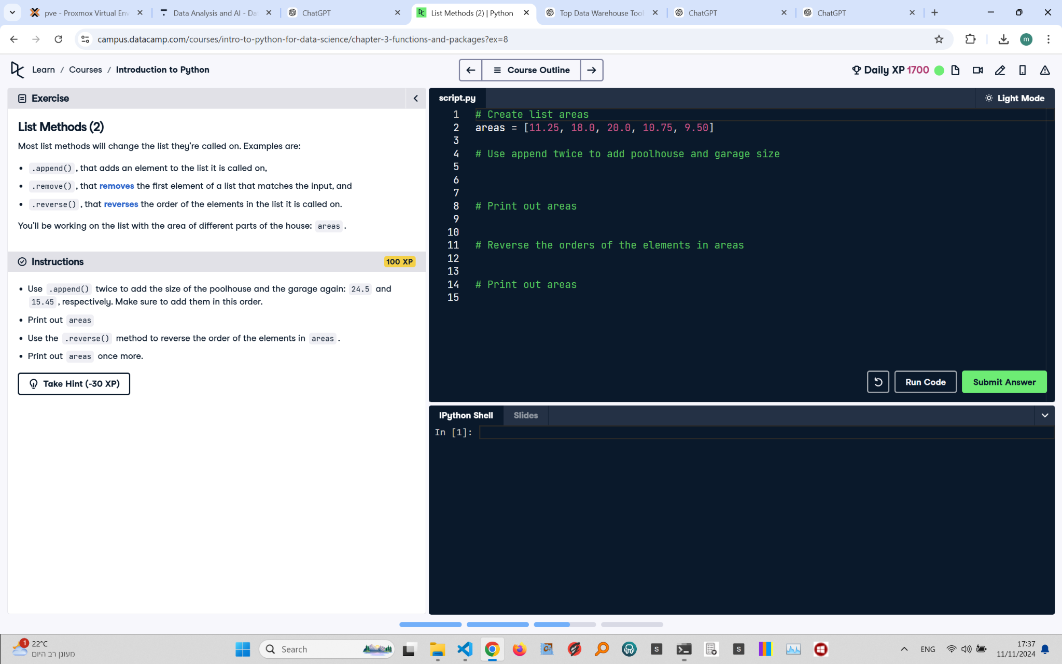

## Recreated Question and Terminal

List Methods (2)  
Most list methods will change the list they’re called on. Examples are:

- .append(), that adds an element to the list it is called on  
- .remove(), that removes the first element of a list that matches the input, and  
- .reverse(), that reverses the order of the elements in the list it is called on.  
  
You’ll be working on the list with the area of different parts of a house: areas.

Instructions:  
- Use .append() twice to add the size of the poolhouse and the garage again: 24.5 and 15.45, respectively. Make sure to add them in this order.  
- Print out areas.  
- Use the .reverse() method to reverse the order of the elements in areas.  
- Print out areas once more.

## Answer

# Create list areas  
areas = [11.25, 18.0, 20.0, 10.75, 9.50]  
  
# Use append twice to add poolhouse and garage size  
areas.append(24.5)  
areas.append(15.45)  
  
# Print out areas  
print(areas)  
  
# Reverse the orders of the elements in areas  
areas.reverse()  
  
# Print out areas  
print(areas)

## Explanation of the Answer

The .append() method is used to add 24.5 and 15.45 to the end of the list areas. The .reverse() method is then called to reverse the order of all elements in the list. The print() function is used to display the list before and after reversing.